7th Grade Supply List
Please bring the following items to school to ensure a successful and organized year.
ELA
- 2 inch binder
- 1 pack of dividers
MATH
- 1 pack of dividers
- Texas Instrument Scientific Calculator
Model: TI-30XS Multiview (no substitutions)
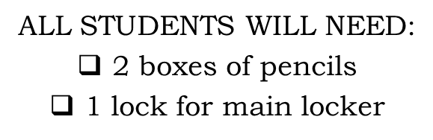
- 1 pack of loose leaf paper
- Box of pencils
- Small pack of pencil top erasers
- 3 Ring Binder- 2 inch
SCIENCE
- 1 inch binder (for new students only)
- 1 pack of dividers
SOCIAL STUDIES
- 1 pocket folder
- Highlighters
- 1 composition notebook
STRATEGIES
- 1 pocket folder with 3-hole center
WRITING
- 1 inch binder
- 1 pack of 25 plastic page protectors
- 1 pair of ear buds to be kept in class

HOMEROOM (to be given to advisor)
- 3 boxes of tissue

PHYSICAL EDUCATION
- Appropriate shorts/sweatpants, T-shirt (different than those worn to school)
- Sneakers (NO hiking boots, platform shoes, or loafers)
- Deodorant/Antiperspirant
- Lock for Physical Education Locker

OPTIONAL SUPPLIES
- Colored Pencils/Markers
- Index Cards (3x5)
- Soft pencil case for carrying writing implements from class to class

PHOTO
- SD Memory Card 8GB

Important Notes

-Please pre-label binders for classes

-Additional items may be requested in
September when classes are finalized

-Middle School Students WILL NOT be allowed to carry backpacks from class to class. Backpacks and jackets must remain in student lockers.

