8th Grade Supply List
Please bring the following items to school to ensure a successful and organized year.
ELA/Writing
- (2) two inch binders
- 1 pack of dividers

MATH
- 1 pack of dividers
- 3 inch 3 ring binder
- 1 composition notebook
- Texas Instrument Scientific Calculator
Model: TI-30XS Multiview (no substitutions)
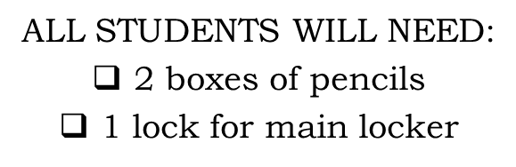
- 2 packs of loose leaf paper
- Box of pencils
- Small pack of pencil top erasers

SCIENCE
- 1 inch binder (for new students only)
- 1 pack of dividers

SOCIAL STUDIES
- 1 pocket folder
- 2 packs of dividers
- Hi-liters

HOMEROOM
- 1 Soft pencil case for carrying writing implements from class to class
- 3 boxes of tissue

Photo
- SD Memory Card 8GB

PHYSICAL EDUCATION
- Appropriate shorts/sweatpants, T-shirt (different than those worn to school)
- Sneakers (NO hiking boots, platform shoes, or loafers)
- Deodorant/Antiperspirant
- Lock for Physical Education Locker

Important Notes

-Please pre-label binders for classes

-Additional items may be requested in
September when classes are finalized

-Middle School Students WILL NOT be allowed to carry backpacks from class to class. Backpacks and jackets must remain in student lockers.

